









There is no error.



**Implementation Phase: Final Output(no error)**

**Step 1: Create a New Project**

**Select "Empty Activity" and click Next.**

**Enter the project details:**

* + **Name: Layout**

**Modify Strings.xml**

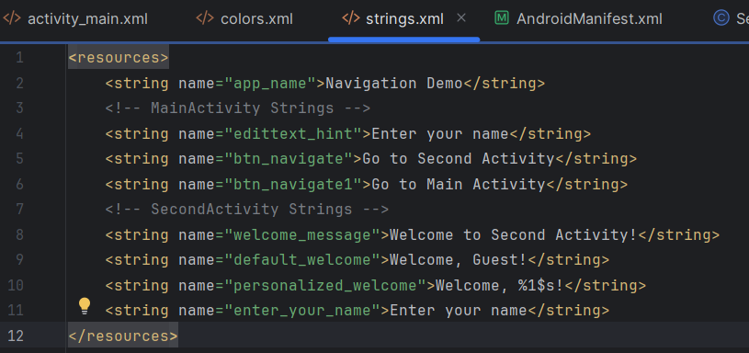

**Modify colors.xml**

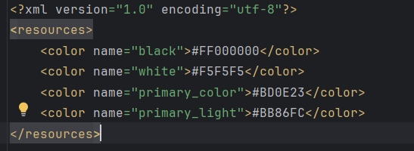

**Implementation Phase: Final Output(no error)**

**Modify the Layout (activity_main.xml)**

1. **Open res/layout/activity_main.xml**

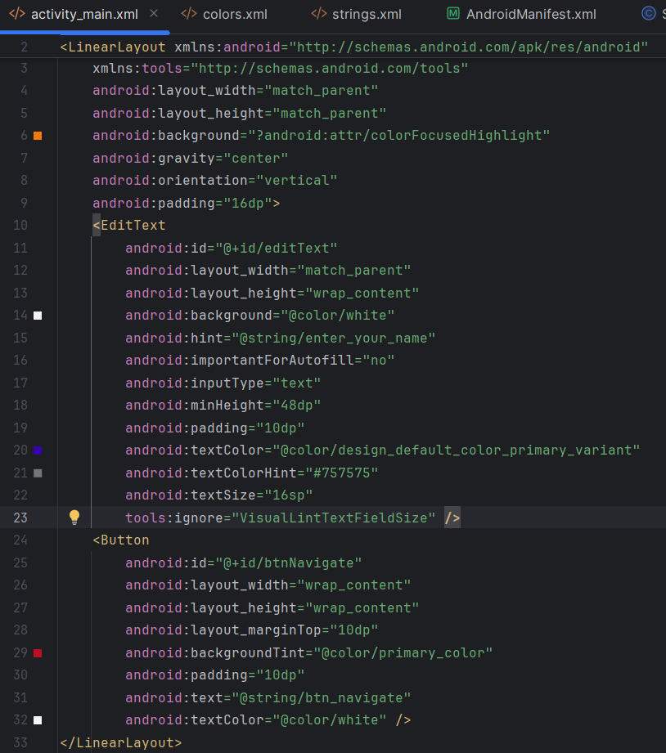

**Modify the Layout (activity_second.xml)**

1. **Open res/layout/activity_second.xml**

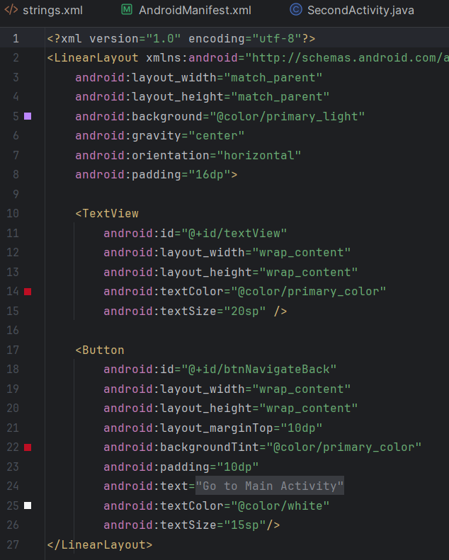



**Implementation Phase: Final Output(no error)**

**Modify MainActivity.java**

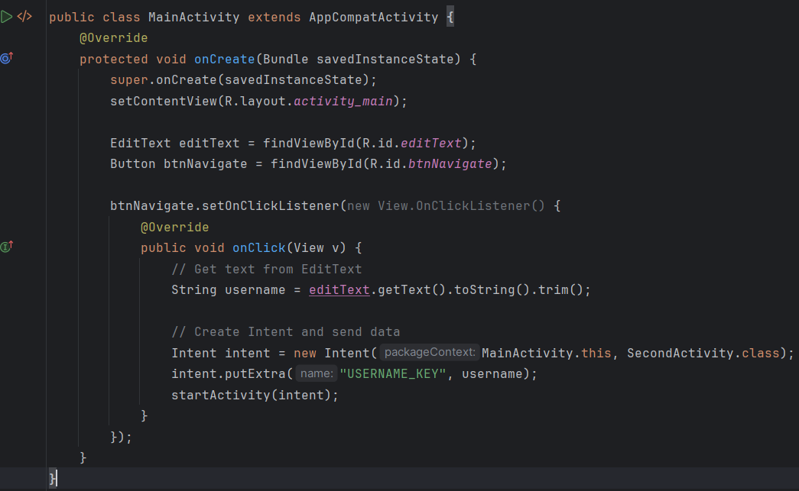

**Modify SecondActivity.java**

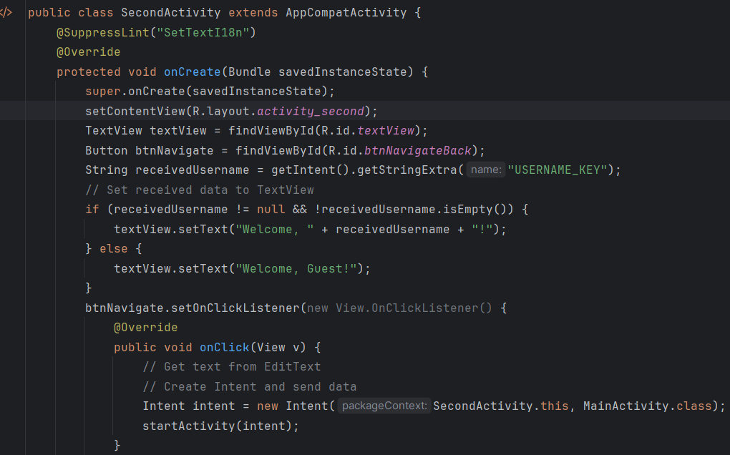

**Implementation Phase: Final Output(no error)**

**Check the layout preview**

**Activity_main.xml**

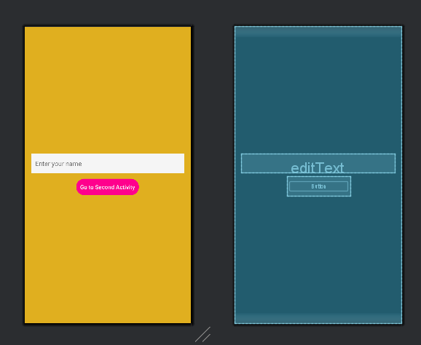

**Activity_second.xml**

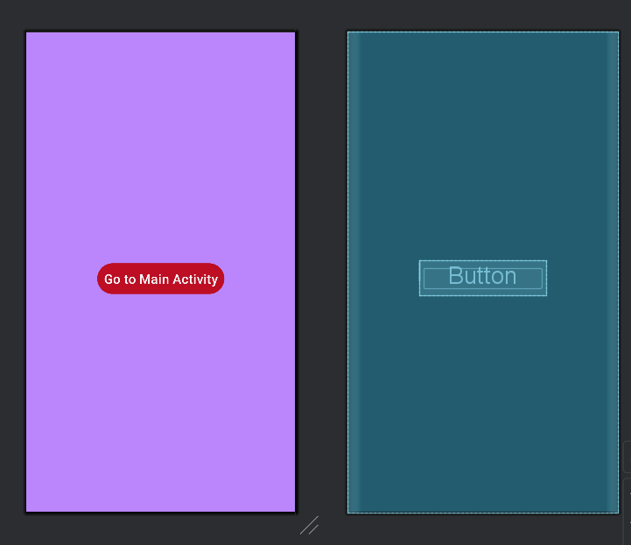



1. **Click Run**
2. **Select an emulator or a connected Android device.**





        
        
        
        
        
        
        
        
        

